© UBC Biology 121 2020 Reading Phylogenetic Trees Worksheet

**ANSWER KEY**

|  |  |  |  |  |  |  |  |  |  |  |  |  |
| --- | --- | --- | --- | --- | --- | --- | --- | --- | --- | --- | --- | --- |
| **Collagen** | |  | **13** | **Vertebrates** | | | | | **\*** | | **Animals** |  |
| **Extracellular matrix** | | |  |
|  |  |  |  |  |  |
|  |  |  |  |  |  |  |
| **Tight junctions** | | **12** |  | **Insects** | | **\*** | |  |  |  |  |  |
|  |  |  |  |  |  |  |  |
|  |  |  |  |  |  |  |  |  |  |
|  | **11** |  |  | **Sponges** | | | **\*** | |  |  |  |  |
|  |  |  |  |  |  |  |  |
|  |  |  |  |  |  |  |  |  |  |
| **Single flagellum** | **10** |  |  | **Choanoflagellates** | | | | | | |  |  |
|  |  |  |  |  |
| **Insertion in EF1a gene** |  |  |  |  |  |  |  |  |  |  |  |  |
| **7** |  |  |  | ***Capsaspora*** | | | | |  |  |  |  |
| **6** |  | **8** |  | **Fungi** | **\*** | |  | **\*** | |  |  |  |
|  |  |  |  |  |  |  |  |  |  |
|  |  |  | **9** | ***Fonticula*** | | | |  |  |  |
|  |  |  |  |  |  |  |  |
|  |  |  |  |  |  |  |  |  |  |  |  |
|  |  |  |  | ***Nuclearia*** | | | |  |  |  |  |  |
| **3** |  |  |  | **Breviatea** | | |  |  |  |  |  |  |
| **Nucleus** |  |  |  |  |  |  |  |  |  |
|  |  |  |  |  |  |  |  |  |  |  |  |
| **Cytoskeleton** |  |  |  | **Slime molds** | | | | | | **\*** |  |  |
| **Organelles** |  | **4** |  |  |  |
|  |  |  |  |  |  |  |  |  |  |
| **2** |  |  |  | **Shelled amoebae** | | | | | | |  |  |
|  |  |  | **5** |  |  |
|  |  |  |  |  |  |  |  |  |  |  |  |
| **1** |  |  |  | ***Amoeba*** | | |  |  |  |  |  |  |
|  |  |  |  |  |  |  |  | **\*** | |  |  |
|  |  |  |  | **Land plants** | | | | |  |  |
|  |  |  |  |  |  |  |  |
|  |  |  |  | **Archaea** | | |  |  |  |  |  |  |
|  |  |  |  | **Bacteria** | | |  |  |  |  |  |  |

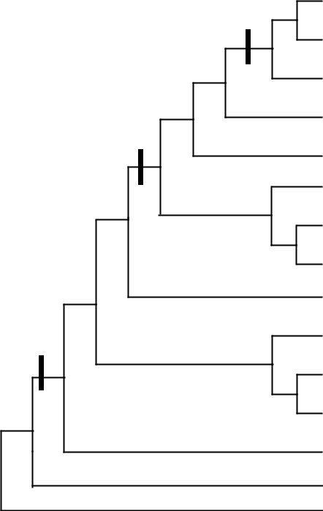

* **= multicellular lineage**

|  |
| --- |
| **Eukaryotes** |



|  |
| --- |
| **Opisthokonts** |

Question 1.

1. Is a group composed only of Fungi and *Fonticula* monophyletic? Justify your answer.

*No. A monophyletic group is a group of the groups/species (e.g. Fungi and Fonticula), plus their most recent common ancestor, plus all of this ancestor’s descendants. The most recent common ancestor of Fungi and Fonticula has several descendants: Fungi and Fonticula, but also Nuclearia, and the most recent common ancestor of Fonticula and Nuclearia.*

1. Identify a monophyletic group of your choice that includes choanoflagellates. List all of the members of this group and the node of the common ancestor.

*Any node on the backbone of the tree except node 12 or 13 would be ok. Two examples:*

* + *Opisthokonts The monophyletic group with common ancestor at node 7. This group includes: Fungi, Nuclearia, Fonticula, Capsaspora, Choanoflagellates, Sponges, Insects and Vertebrates.*
  + *The monophyletic group of animals + choanoflagellates is another example, with common ancestor at node 11. Members Choanoflagellates, Sponges, Insects and Vertebrates.*

1. On the tree, identify and circle the most recent common ancestor of land plants and animals. *Node 2*

© UBC Biology 121 2020

1. Assume that multicellularity can be gained but not lost.

According to this tree, how many times has multicellularity evolved within eukaryotes? On the tree, mark all branches where multicellularity arose with a star.

*5 times, in the Ancestor of:*

* + *Fungi*
  + *Animals*
  + *Fonticula*
  + *Slime molds*
  + *Land plants*

1. A new species is discovered that has an insertion in the EF1a gene and a single flagellum. This new species is multicellular, but does not have collagen or extracellular matrix. What clade or lineage might this new species belong to? Justify your answer.

*This clade might be related to Fonticula or Fungi, both of which are multicellular opisthokonts, but not animals.*

1. i. Do shelled amoebae have a nucleus? Why or why not?

*Yes, this trait appears in the recent common ancestor of eukaryotes and shelled amoebae are eukaryotes.*

ii. Do archaea have organelles? Why or why not?

*No, this trait appears in the most recent common ancestor of eukaryotes, after archaea have branched away from eukaryotes.*

1. Is it accurate to say that *Capsaspora* are more ancient than animals? Explain your answer.

*No: both Capsaspora and animals are alive today, and have been evolving from the same length*

*of time. (Remember what the smart platypus says: “Early branching does not equal ancestral/primitive/ancient”!!!)*

1. A lot of basic research in molecular and cell biology is performed on yeast (a fungus), and the results are typically well applicable to mammalian cells.

Bacteria such as *E. coli* are even cheaper and easier to culture, and their biology is extremely well known (*E. coli* is the organism that we know the most about in the whole world). Still, yeast is a much better model organism. What is a likely reason for this?

*If we want a model organism that provides results that are applicable to mammalian cells, we need an organism that is closely related to mammals. Mammals are animals, and yeast, which is a fungus, is more closely related to animals than bacteria are, since animals and fungi have a more recent common ancestor than animals and bacteria.*

2

© UBC Biology 121 2020

**Question 2.**

Which of the trees represented below show the same phylogenetic relationships as each other? Briefly justify your answer.

* *Trees 1 and 4 show the same relationships: C, D and their most recent common ancestor form a monophyletic group, this most recent common ancestor (call it “X”) derives from an ancestor that gave B and X (so, B, C, D, X and their most recent common ancestor from a monophyletic group), and this most recent common ancestor (call it “Y”) derives from another ancestor, which gave A and Y.*
* *Tree 2 shows different relationships: B, C and their most recent common ancestor are a monophyletic group, which is not seen in any other tree.*
* *Trees 3 and 5 Show the same relationship. However, the timing of the branching of CD is different in 3 and 5.*

**Question 3.** The two trees above represent two hypotheses about the relationships within animals. Does one or more hypothesis suggest that sponges are more closely related to cnidarians than to comb jellies? Justify your answer.

*According to the New tree, sponges are more closely related to cnidarians than to comb jellies (sponges and cnidarians share a more recent common ancestor that either does with comb jellies).*

*However, according to the Traditional tree sponges are equally related to comb jellies and cnidarians (all three share the same common ancestor)*

3